Abstract:
Keywords:
- INTRODUCTION
Timetable scheduling is a critical yet complex task in educational institutions, involving the optimal allocation of courses, faculty, and rooms under numerous hard and soft constraints. As institutional size and scheduling requirements grow, traditional manual methods become increasingly inefficient, error-prone, and difficult to scale (Bhavadharani et al. [5]). The problem is inherently NP-Hard, making it impractical to solve using exact algorithms for large instances. Consequently, heuristic and metaheuristic approaches have been widely adopted. Among these, Genetic Algorithms (GA) have shown significant promise due to their adaptive nature and effectiveness in exploring large solution spaces. GA-based systems evolve populations of candidate solutions through operations such as selection, crossover, and mutation to produce conflict-free and near-optimal timetables (Alsmadi et al. [6]). In this study, we propose an improved GA-based timetable generation system designed to address these issues. Our approach emphasizes better constraint satisfaction, integration of user preferences, and a scalable design suitable for institutional deployment.

- LITERATURE SURVEY
- Various approaches have been proposed to address the timetabling problem, ranging from graph-based models and constraint satisfaction to heuristic and metaheuristic algorithms. Among them, Genetic Algorithms (GA) have stood out due to their adaptive nature and ability to explore large solution spaces effectively. Customized genetic operators, such as row-based crossover and order-k mutation, have been employed to tackle highly constrained school timetabling problems. These are often combined with local search and a repair mechanism to correct infeasibility [1]. Constraints that must be satisfied during scheduling are typically classified into hard and soft constraints. These include minimizing idle gaps between student lectures and ensuring an even distribution of teaching assignments across the week [2]. Scalability and real-time adaptability have also been addressed using GA. A system employing roulette wheel and tournament selection, single-point crossover, and mutation—combined with a weighted fitness function to evaluate constraint violations—achieved 95% conflict resolution and 90% resource utilization on real-world university data [3]. GA has also been combined with Dynamic Programming (DP) to solve joint course timetables. While GA is used to optimize time slot assignments through swap-based mutation and a repair mechanism, DP is employed for classroom allocation to reduce seat wastage and enhance utilization. This hybrid approach has outperformed methods such as Particle Swarm Optimization, Ant Colony Optimization, and the Producer-Scrounger method across metrics like fitness and occupancy rate [4]. Another technique utilizes dynamic chromosomes that adapt to varying course loads across departments and semesters. Scheduling variables are encoded as tuples of course, time, and room. This system applies roulette wheel selection, two-point crossover, and optimized mutation to achieve up to 93% conflict-free timetables in under five minutes [5]. A hybrid approach integrating GA with graph coloring has also been proposed. Courses are modelled as graph nodes and conflicts as edges to prevent time slot overlaps. Each timetable is represented as an array of genes, where each gene includes course, instructor, room, and time slot. A penalty-based fitness function is used to evaluate violations of hard and soft constraints [6]. These studies highlight the effectiveness of GA-based and hybrid approaches in resolving complex timetabling constraints. The research continues to evolve toward more efficient, scalable, and real-time systems that can meet the dynamic needs of educational institutions.

- EXISTING SYSTEM
Timetable generation has long been a complex scheduling problem due to the presence of multiple hard and soft constraints, including room availability, faculty workload, and subject-hour distribution. Many institutions still rely on manual scheduling, where teachers or coordinators physically create timetables while accounting for institutional constraints and limitations. This process is time-consuming, error-prone, and difficult to scale for large academic setups. Several works have applied GA in different forms—such as constraint-weighted models (Abdelhalim & El Khayat [2]), hybrid approaches (Han & Wang [13]), and preference-based scheduling (Mahlous & Mahlous [40]). Despite these advances, limitations persist regarding dynamic adaptability, real-time editing, and scalability across departments (Paramatmuni et al. [43]; Febrita & Mahmudy [47]; Paper 30).

- Limitations of Existing System
- Limited support for Soft Constraints such as faculty preferences, load balancing.
- Minimal User interaction, especially in systems without web-based or collaborative interfaces.
- Lack of real-time adaptability for handling sudden changes like room unavailability.
These limitations highlight the need for a more flexible, adaptable, and user-centric solution.

- PROPOSED METHODOLOGY
Timetable generation is a complex combinatorial optimization problem, classified as NP-hard due to its large solution space and strict constraints. The proposed method employs a Genetic Algorithm to generate conflict-free and optimized academic timetable based on institutional constraints and faculty preferences.

Problem Modelling
The objective is to generate a timetable that assigns all classes (theory and lab) to valid time slots such that:
Hard constraints are satisfied:
  - No overlapping classes for the same semester.
  - No faculty member is assigned to multiple classes simultaneously.
  - Labs span exactly two consecutive periods within daily limits.
Soft constraints are optimized:
  - Faculty preferences for specific time slots are honoured.
  - Lab sessions avoid crossing breaks like recess or lunch.

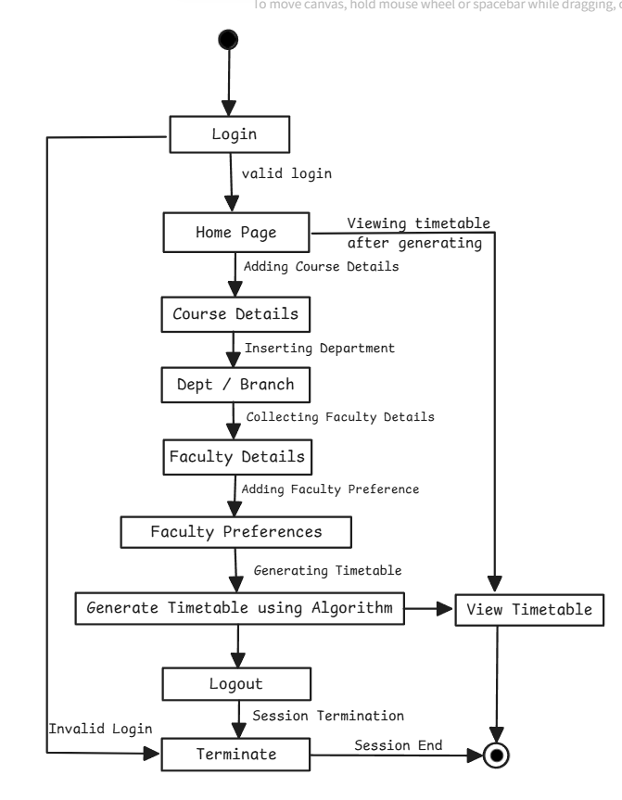

- Genetic Algorithm (GA)
Genetic algorithms (GAs) are metaheuristic optimization techniques inspired by the principles of natural selection, designed to explore large and complex solution spaces efficiently. They rely on flexible, adaptive frameworks, making them particularly effective in dynamic environments. GAs is employed to automatically construct class schedules that not only satisfy hard constraints but also optimize soft constraints. A self-adaptive approach (evolution) further enhances their effectiveness by allowing the algorithm to adjust its parameters or strategies based on problem-specific feedback during execution.

- Population Initialization
Population initialization involves generating a diverse set of candidate timetables, each representing a unique assignment of classes to time slots. In this implementation, initialization is purely random to encourage diversity and avoid early stagnation.

- Chromosome Representation
A chromosome represents a list of scheduled class instances, with each gene encoding one scheduled class, including its assigned day, period, faculty, and type (lab or theory). This structure supports both hard and soft constraint evaluations.

Each chromosome encodes a full academic timetable as a list of Scheduled Class genes. Each gene comprises:
Semester ID, Course ID, Faculty ID’s, Day of the week (Monday–Saturday), Start period (1–7), Duration (1 for theory, 2 for lab)

- Fitness Evaluation
Fitness evaluation quantifies the quality of a timetable by using penalty-based scoring system. Hard constraints incur high penalties to ensure feasibility, while soft constraints guide the optimization toward preferred scheduling patterns. Hard constraints must be strictly enforced, while soft constraints are preferred but flexible.

A penalty-based fitness function is used. The total fitness of a chromosome is the negative sum of penalties for constraint violations:
- Hard Constraint Penalties:
  - Semester or faculty time conflicts: +1000
  - Scheduling during faculty blocked slots: +500
  - Invalid lab durations or boundaries: +500
- Soft Constraint Penalties:
  - Not scheduled in preferred slots: +10
  - Labs scheduled across breaks: +5

The fitness is calculated as:
- Fitness=−∑(penalties)\text{Fitness} = - \sum \text{(penalties)}Fitness=−∑(penalties)
A higher fitness score (closer to 0 or positive) indicates a better timetable.

- Selection
Selection identifies high-quality timetables for reproduction. This implementation uses tournament selection, where groups of chromosomes compete and the fittest are selected, encouraging stronger candidates to propagate.

- Crossover
Crossover recombines two parent timetables by exchanging time assignments beyond a randomly chosen point, preserving order and structure while introducing variation into the offspring.

- Mutation
Mutation introduces random changes in a chromosome by reassigning new time slots to individual classes with a small probability. This maintains diversity in the population and enables broader search of the solution space.

- Evolution and Termination
Termination occurs either when a feasible timetable meeting all hard constraints is discovered or when a predefined number of generations is completed, ensuring bounded computation time.

The GA proceeds for a pre-defined number of generations or until an optimal chromosome (fitness ≥ 0) is found. In each generation:
- Fitness scores are updated.
- Parents are selected.
- Crossover and mutation are applied.
- A new population is formed.
- The best individual is tracked.
Early stopping is triggered if a feasible solution is found before the maximum generation count.

- DESIGN AND IMPLEMENTATION
A. System Architecture
The application follows a modular three-layer architecture:
Frontend: Streamlit-based web interface for user interaction.
Backend: Python modules and Postgres database for logic and data storage.
GA: genetic_algorithm.py handles timetable generation and optimisation.
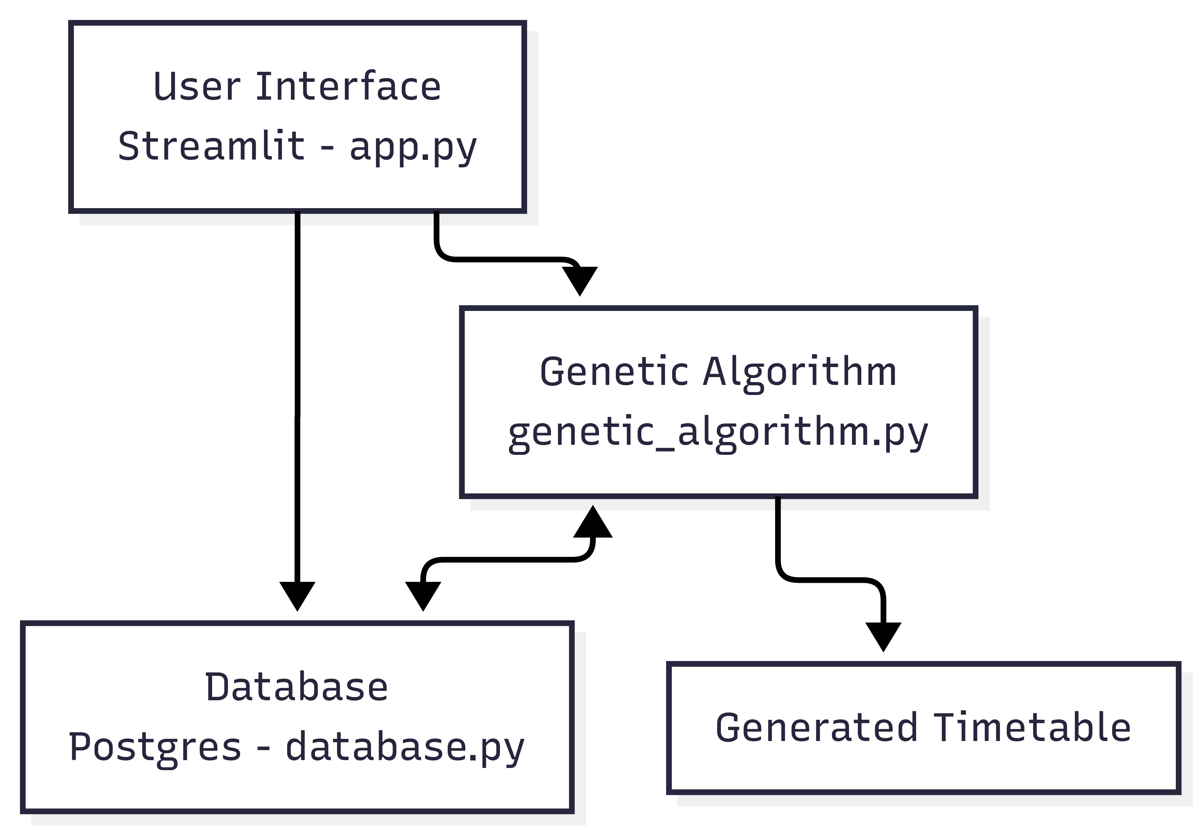
System architecture of web application.
Fig 2 The system consists of a Streamlit-based user interface (app.py) for input and all user interactions, a PostgreSQL database for storing academic data (database.py), and a genetic algorithm engine (genetic_algorithm.py) responsible for generating optimized timetables based on user-defined constraints.

- User Interface:
A Streamlit-based web interface allows users to input data and visualize the generated timetable.
  - Authentication: User registration and login with password hashing.
  - Entity Management: Forms to add/edit departments, semesters, faculty, and courses.
  - Mappings: Assign theory/lab courses to faculty.
  - Preferences: Set preferred slots per faculty.
  - GA Parameters: Set population size, generations, mutation and crossover rates.
  - Output Display: Tabular timetable display
- Data Storage:
Data is retrieved from structured inputs containing semester,courses, faculty assignments, and preferences.
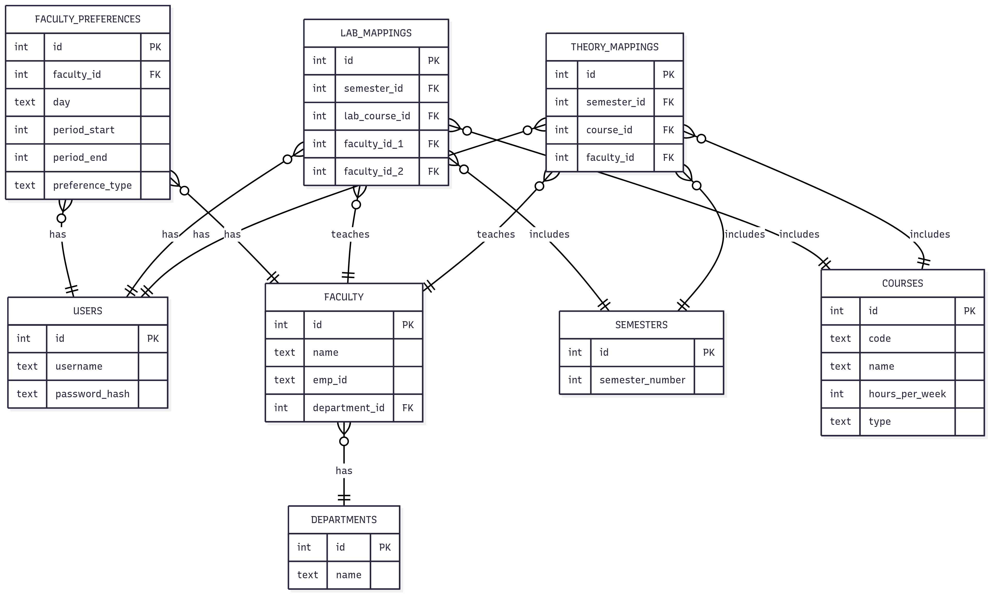
(3) illustrates the database schema
The database schema (3) efficiently models the core entities involved in timetable generation, including faculty, courses, semesters, and departments. It captures course-to-faculty assignments through theory and lab mappings, while faculty availability is handled via preference records. The structure ensures data integrity through foreign keys and supports constraint-based scheduling, forming a solid backend for the Genetic Algorithm driven timetable generation system.

- RESULT AND ANALYSIS
- Login page
The user authentication interface allows registered users to securely log in to access the timetable generation system.
- Add Department
This module enables administrators to add and manage academic departments for course and faculty mapping.
- Add Teacher and Subject
Faculty and course details are added and mapped to ensure proper allocation during timetable generation.
- Add Classroom
Classroom data is recorded to facilitate space allocation and avoid scheduling conflicts.
- Generate Timetable
The final timetable is displayed in a structured format, showing class schedules for each semester.

- CONCLUSION
- FUTURE WORK
- REFERENCES

- ACKNOWLEDGEMENT

